# Task 4.1P Answer Sheet

Name: Tran Thanh Minh

Student ID: 103809048

1. How many Counter objects were created?

A total of 3 Counter objects

## Variables declared in main() are different to the objects created when we call new. What is the relationship between the declared variables in main and the objects created?

The relationship is the variable holds a reference to the object in the memory. Means when I create an object to a variable, I also set variable’s location in the memory to the object store. In this case when I create myCounters variable, I also assign the Counter Object to the variable’s location.

1. Resetting the counter in myCounters[2] also changes the value of the counter in myCounters[0]. Why causes this to happen?

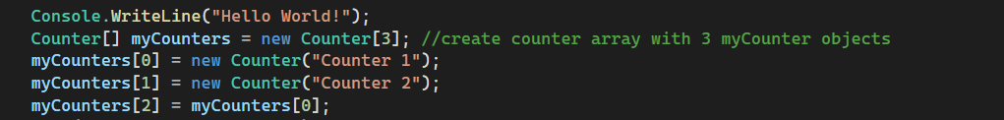

Before resetting :

After resetting :

Because both myCounter[2] and myCounter[1] are pointed and referred to each other so when one change, the other change too.

## The key difference between memory on the heap compared to the stack and the heap is that the heap holds dynamically allocated memory. What does this mean?

It means the allocated memory on the heap can me adjusted and stored while working for flexibility purposes.

## On which are objects allocated (heap or stack)? On which are local variables allocated (heap or stack)?

Object’s data (Counter) allocated in the heap, while the object refer to the local variable (myCounters) allocated in the stack. Local variables are created on the stack.

1. What does the new() method do when called for a particular class What does it do and what does it return?

New() method will call the demanded constructor to initialize the object and will also create new object’s field and its property. It return the reference to the object after creating, this reference will assign to the local variable like I have written above.

## Draw a diagram showing the locations of the variables and objects in main and their relationships to one another.

Main

myCounters[3]

i

c

PrintCounters( i , c )

Stack

Heap

Counter

_name

_count